Sare, Avyel John D.

INF 255 – 1st Assignment

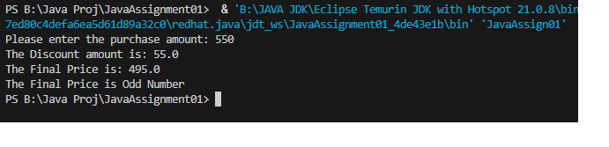

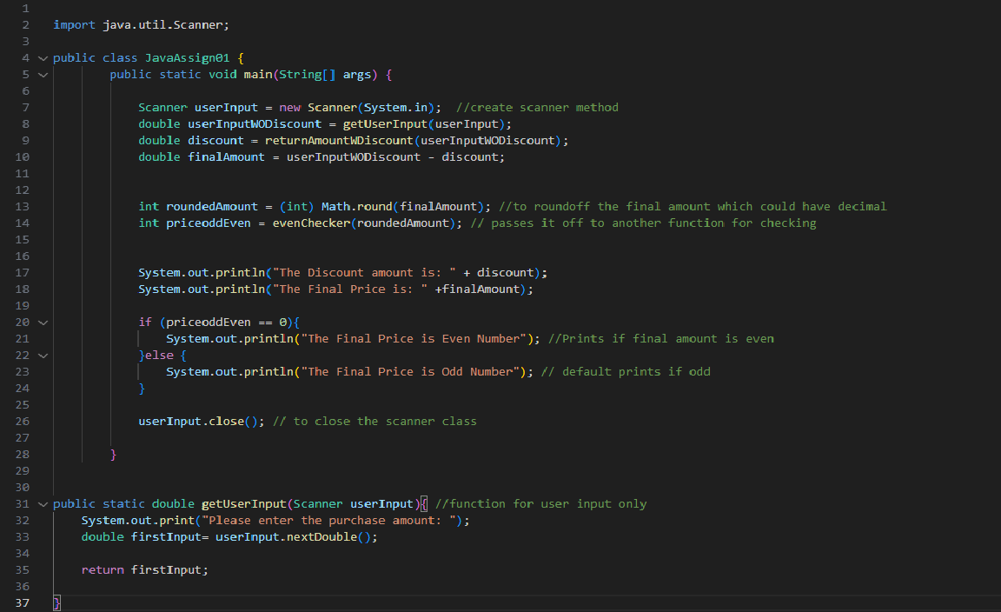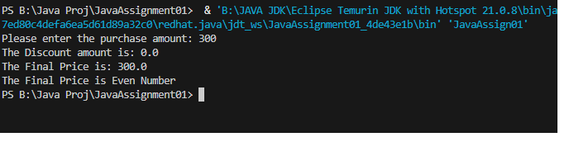

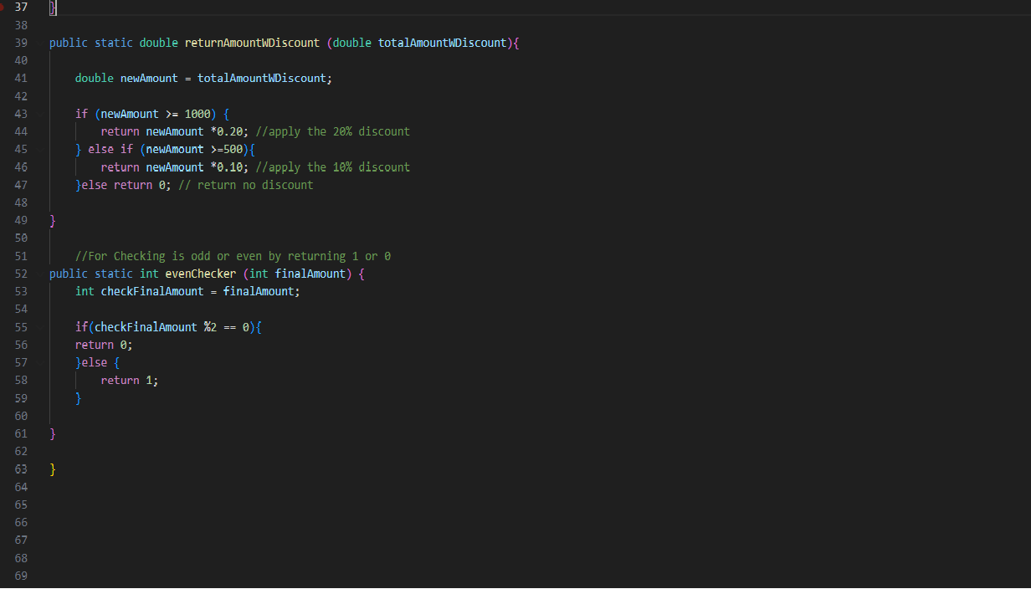

https://github.com/vieljohn/firstAssignment_Java/tree/main